General information about the crops
Sorghum (JOWAR)
Season – Kharif
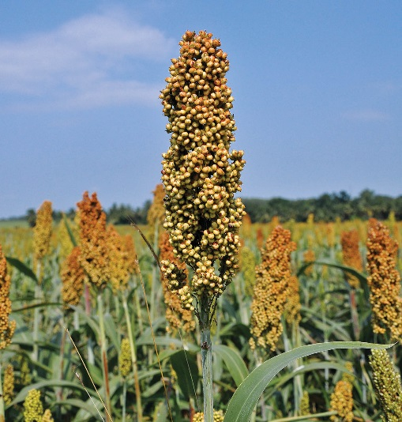

General
- Sorghum is considered to be originated in Northern Africa .
- It is third major food grain crop of India .
- It is used as a Fodder Crop also as an industrial raw material .
- USA is the largest producer of Sorghum .

- Climate
Temp  (18 °C/32°C) | Rainfall  (26°C /30°C)
Sowing Temperature  (25 -30°C) | Harvesting Temperature  - - 18°C)

- Popular variety with their Yield.
Variety | Yield
HI 513 | 200qtl/acre
HC | 308qtl/acre
HC 260 | 152qtl/acre
HC 171 | 160qtl/acre
HC 136 | 160qtl/acre
Sweet sudan | 300 qtl/acre
Haryana chari | 120qtl/acre

- Land preparation

- Give one deep ploughing every year in shallow to medium deep soill.
- Give one to three ploughing followed by 2 criss cross harrowing .
- Prepare land in such a way that water stagnation will not occurred in field .

- Sowing

- In kharif season , optimum time for sowing is from 25th June to 10th of July and spacing is 45cm×15cm. and in Haryana , it is sown by seed drill or pora method.

- Seed Rate

- Seed rate is 20 – 24 kg /acre .

- Seed Treatment

- To protect crop soil borne disease , do seed treatment with 300 mesh Sulphur powder24gm and then Azotobacter@25 gm/kg of seed before sowing .

- Fertilizer Requirement
Condition | Urea(Kg/acre) | SSP (kg/acre) | MOP (Kg/acre)
Irrigated | 12 | 100 | As per soil test result

Fertlizer Application
Apply nitrogen in the form of Urea@12kg/acre and Phosphorous in the form of Super Phosphate2100kg/acre at the time of sowing .

- Weed Control

- Jowar crop get affected due to both grassy and broad leaves .
- Do manual weeding with the help of Khurpi 15-20days after Sowing .
- Spray with Atrazine@500gm/150litre water within 7 – 15 days after Sowing .

- Irrigation

- Tillering , Flowering and grain formation satges are critical stages for Irrigation .
- In kharif season it required1 or 3 irrigation depending upon Rainfall intensity .
- Under adequate water supply in Rabi and summer season, irrigation should be given at all these critical stages .

- Harvesting

- For fodder purpose , harvest the crop after Flowering stage .
- For single cut varieties , carry out harvesting 60 – 65 days after Sowing ( Crop is at 50%flowering ) .
- Whereas for multicut varities , take first harvesting at 60 days after sowing and second harvesting 40 days first harvesting .
- For grain purpose , harvest it when grain become hard and contain less than 25% moisture .

- Storage
Grain at or below 14% percent moisture is considered dry. For long-term storage (more than 6 months), grain moisture content should be a maximum of 13.5%. Sorghum grain is stored traditionally in mud bins or straw bins or bamboo bins or in metal bins.

